|  |  |  |  |  |  |  |
| --- | --- | --- | --- | --- | --- | --- |
| **Practicum Final Exam – Odd Semester Year 2022/2023** | | | | | | |
| **Subject** | | | **COMP6799001 - Database Technology** | | |  |
| **Class** | **:** | **BE02 | BG01** | | **Start Date** | **: 4 January 2023** |
| **Lecturer** | **:** | **D2823 - Santy, S.Kom., M.Sc., PSM I**  **D6659 - Eko Setyo Purwanto, S.Pd., M.Kom.** | | **Start Time** | **: 15.20** |
| **End Date** | **: 4 January 2023** |
| **End Time** | **: 17.00** |

**PERATURAN UJIAN:**

*Exam Regulations:*

* Mahasiswa tidak diperbolehkan berdiskusi dan/atau bekerja sama dengan peserta ujian lainnya

*Student is not allowed to discuss and/or work together with other exam participants*

* Mahasiswa tidak diperbolehkan untuk membuka dan menyalin dari **BUKU** atau **CATATAN**, **VIDEO** dari pengajar (recording kelas, VBL, Youtube, dsb) dan **REFERENSI** lainnya

*Student isn't allowed to open and copy from any resources such as notes, videos (class recording, VBL, Youtube, etc) and other references*

* Mahasiswa tidak diperbolehkan membuka dan menyalin jawaban dari internet (google, stackoverflow, dsb)

*Student isn't allowed to open and copy answer from the internet (google, stackoverflow, etc)*

* Asisten **BERHAK** memberi nilai 0 **(NOL)** bagi peserta ujian yang melakukan segala bentuk kecurangan

*Assistant is able to give 0 (ZERO) score for exam participant who does any cheating actions*

* Kumpulkan jawaban tepat pada waktunya, apabila terlambat mengumpulkan maka jawaban tidak akan dikoreksi dan nilai mahasiswa adalah 0

*Submit the answer on time, if not, then the answer will not be checked, and the students will receive 0 (ZERO)*

* Bila Anda tidak membaca peraturan ini, maka aanda dianggap telah membaca dan menyetujuinya

*If you have missed to read these regulations, so you are considered to have read and agreed on it*

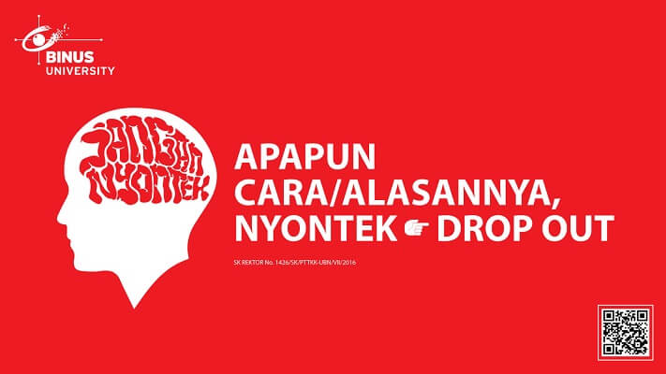

**SOFTWARE YANG DIGUNAKAN:**

*Software will be used:*

* XAMPP 8.0.7

**FILE YANG DIKUMPULKAN:**

*File must be collected:*

* SQL

**PERHATIAN!**

*Attention!*

* Bagi yang mengerjakan tidak sesuai dengan soal, maka akan diberikan nilai **NOL (0)**

*For those who do not work in accordance with the exam case will be marked as* ***ZERO (0)***

* Bagi yang mengerjakan tidak sesuai dengan software dan versi yang telah ditetapkan, maka akan tetap dikoreksi dengan software dan versi yang telah ditetapkan

*For those who do not work in accordance with the software and specific version will be corrected by the predefined software and version*

* Kompres semua jawaban yang akan diunggah. Pastikan format pengumpulan nama file dan ekstensi sesuai dengan format berikut: **[NIM]-[NAMA].zip**

*Compress all file that will be uploaded. Make sure the format for collecting file name and extension according to the following format:* ***[NIM]-[NAME].zip***

**Soal**

*Case*

**GramediaH**

**GramediaH** is a book company that sell books in Jakarta. **GramediaH** provides transaction for every customer who wants to buy books and will be handled by a Staff. The customer can buy more than one book in a transaction.

**Figure 1. ERD**

**Notes**

* Open **create+insert.sql** file (attached with the case), then **execute** the file on **MySQL**
* Please **include the number of the question** in your answer SQL file.

1. **Import** and **use** the database **using SQL query**.
2. Display **CustomerName** and **TransactionDate** for every customer which **TransactionDate** is in **May**.

**(JOIN, MONTH)**

1. Display **ID** (obtaubed from **CustomerID**)**, Name** (obtained from the **uppercase** of **CustomerName**), and **DOB** (obtained from **CustomerDOB**) for every customer whose **date of birth** is **before 2000**. Then, combine it with **ID** (obtaubed from **StaffID**), **Name** (obtained from the **uppercase** of **StaffName**), and **DOB** (obtained from **StaffDOB**)**.**

**(UPPER, YEAR, UNION)**

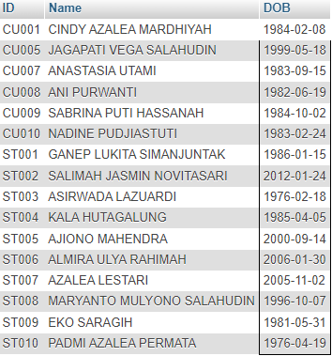

1. Display **TransactionID** (obtained from **TransactionID** by **replacing** "**TR**" with "**Transaction**") and **BookTitle** for every **BookTitle** that **contains "Learn"**. Then, combined it with **TransactionID** (obtained from **TransactionID** by replacing "**TR**" with "**Transaction**") and **BookTitle** for every **TransactionDate** that has **odd month**.

**(REPLACE, JOIN, LIKE, UNION, MONTH)**

1. **Delete column BookPublisherName** from **MsBook** permanently.

**(DROP)**

**Before**

**After**

1. **Delete data** from **MsBook** which the **TransactionDate** is on **Wednesday** and the **length** of the **BookTitle** is **less than 10.**

**(DELETE, DAYNAME, LENGTH)**

**Before**

**After**

1. Display **StaffName**, **CustomerName**, and **TransactionDate** (obtained by **adding 5 days** from the **original TransactionDate**) where **StaffGender** is **Male** and day of **CustomerDOB** is **more** **than 20**.

**(ADDDATE, DAY)**

1. Display **TransactionID**, **BookID,** and **BookTitle** (obtained from **BookTitle** in **uppercase** format). Then, **sort** the data by **BookTitle** in **ascending** format**.**

**(UPPER, ORDER BY)**

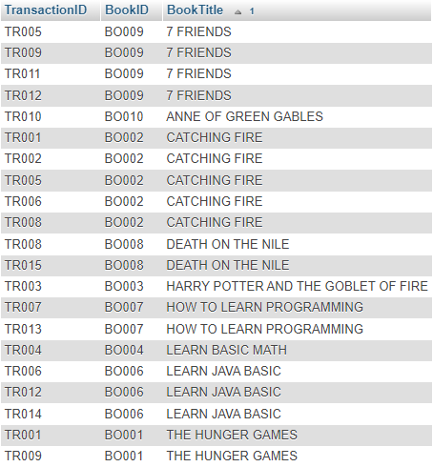

1. Create a **view** named **'BookTransaction'** to display **TransactionID**, **BookTitle** (obtained from **BookTitle** in **lowercase** format), **BookAuthorName,** and **BookPrice** (obtained from **BookPrice** starts with **'Rp. '**) for every transaction which has the **quantity** **more** **than 1**.

**(CREATE VIEW, CONCAT, LOWER)**

1. Create a **view**, named **'LongTitleAtFirstSemester'** to display **TransactionID**, **BookTitle**, **TransactionDate** (obtained from **TransactionDate** with **'Month yyyy' format**) which the transaction happened in the **first half month of the year (January to June)** and the **length** of **BookTitle** is **more than 10**.

**(CREATE VIEW, DATE_FORMAT, MONTH, LENGTH)**

